Module 1 Assignment

Armon Wilson

SNHU CS-230 Operating Systems

1/14/2024

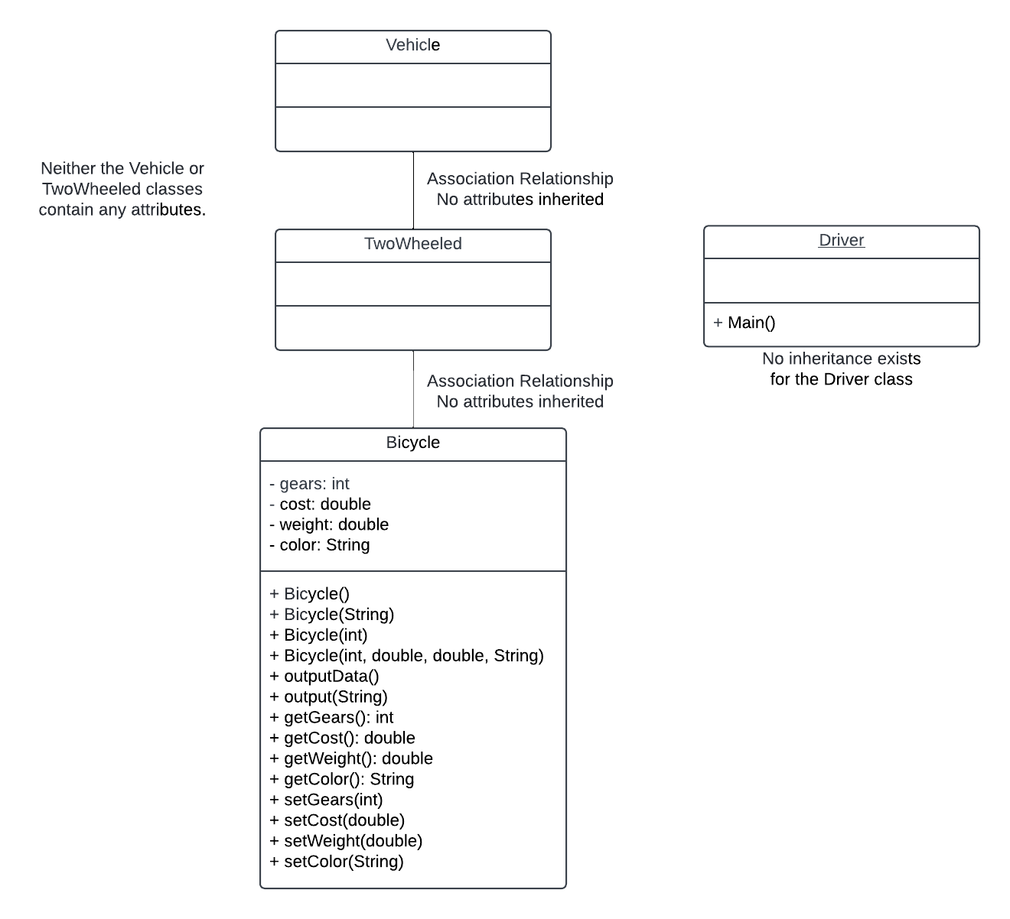

Classes:

* Vehicle:
  + No attributes.
* TwoWheeled:
  + Association Relationship with Vehicle and Bicycle.
  + No attributes.
* Bicycle:
  + Association Relationship with TwoWheeled class.
  + Contains many attributes, of which none are inherited.
  + Can exist on its own without parent classes.
* Driver:
  + Contains only the Main() method.
  + No further relation to any other classes.
  + Underlined for containing the Main() method.